

**Basic Linux Commands Assignments**

Assignment-1

Connect and disconnect with login Access

* What happens when you login a non-existent users or username?
* When non-existent user name is entered it asks for password, after password is entered it displays login incorrect
  + Provide Screenshot and What you understand, explain in short brief?

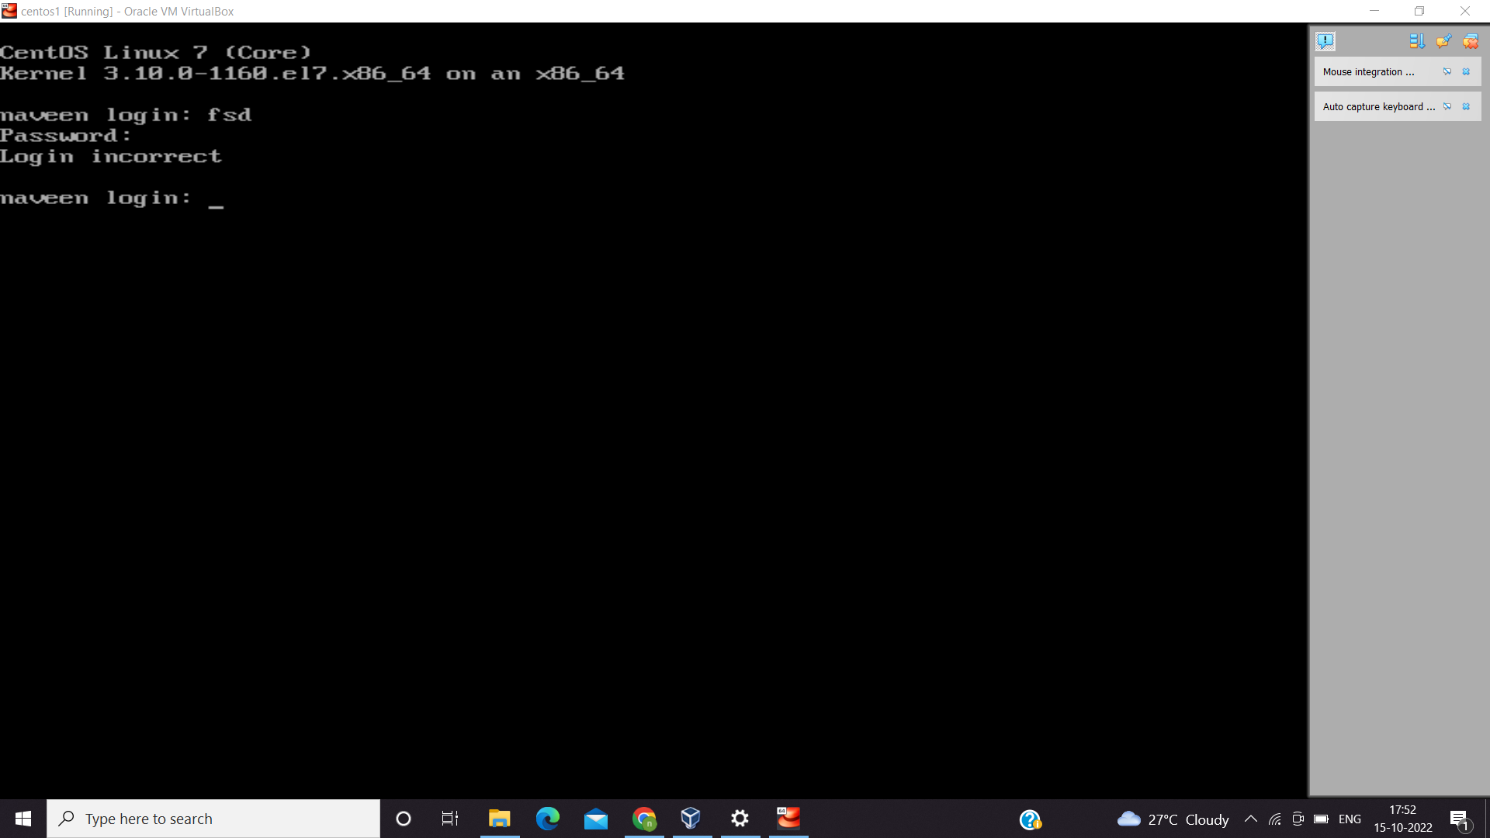

Unless we don’t enter the right credentials we cannot login.

Assignment-2

Password changing

* Login into your account and then change password?
  + Change your password into **IneuR0n#42** and hit the **Enter** key
    - Explain what happen and give screenshot?

-Once command is given it asks for current password, later it asks for new password and asks to confirm password. Once it’s done the password is changed.

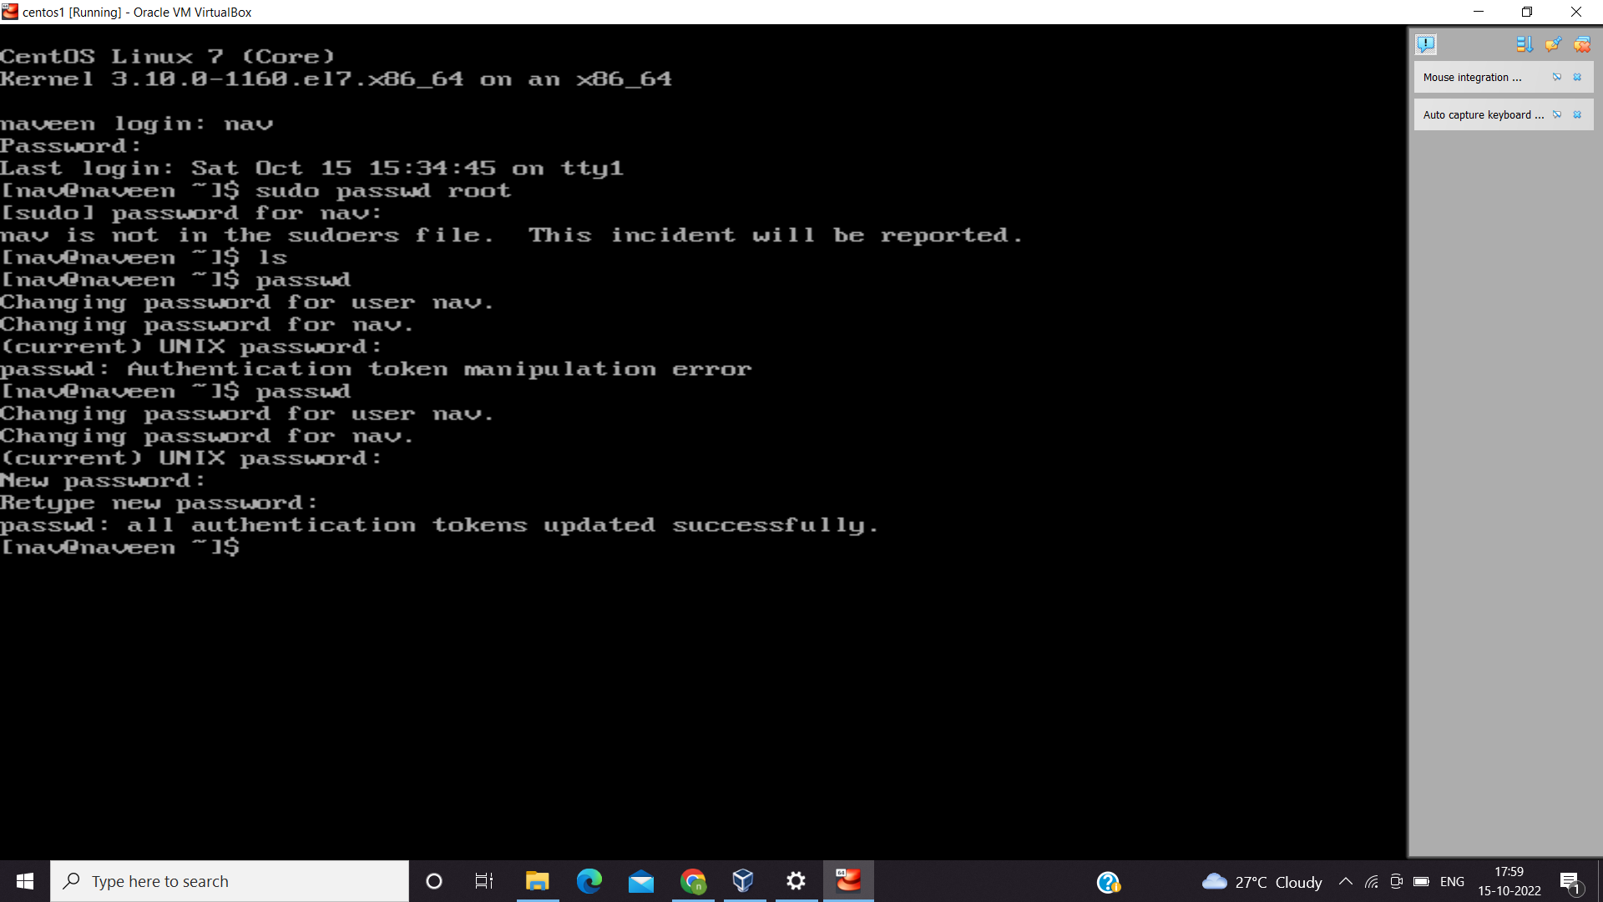

* + Try again to change password but use like password ***1234*** or ***abcd***
    - Explain what happen and give screenshot?

-when we enter keywords of length less than 8 characters, it displays password is shorter than 8 characters.

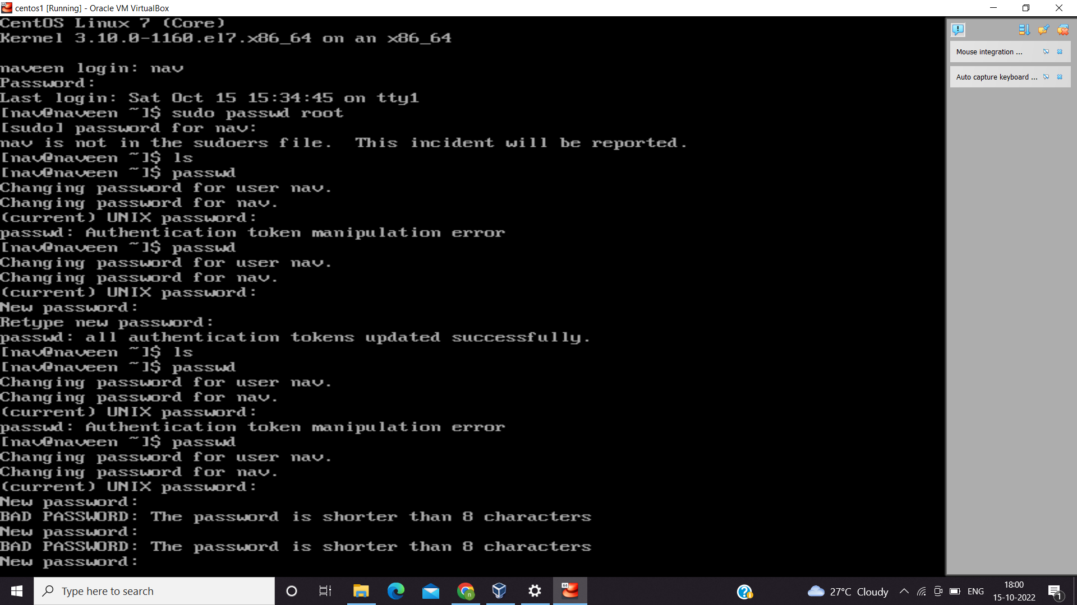

* + Try again to change password but now don’t use any password just hit **Enter** key
    - Explain what happen and give screenshot?

When hit enter key it displays no password supplied.

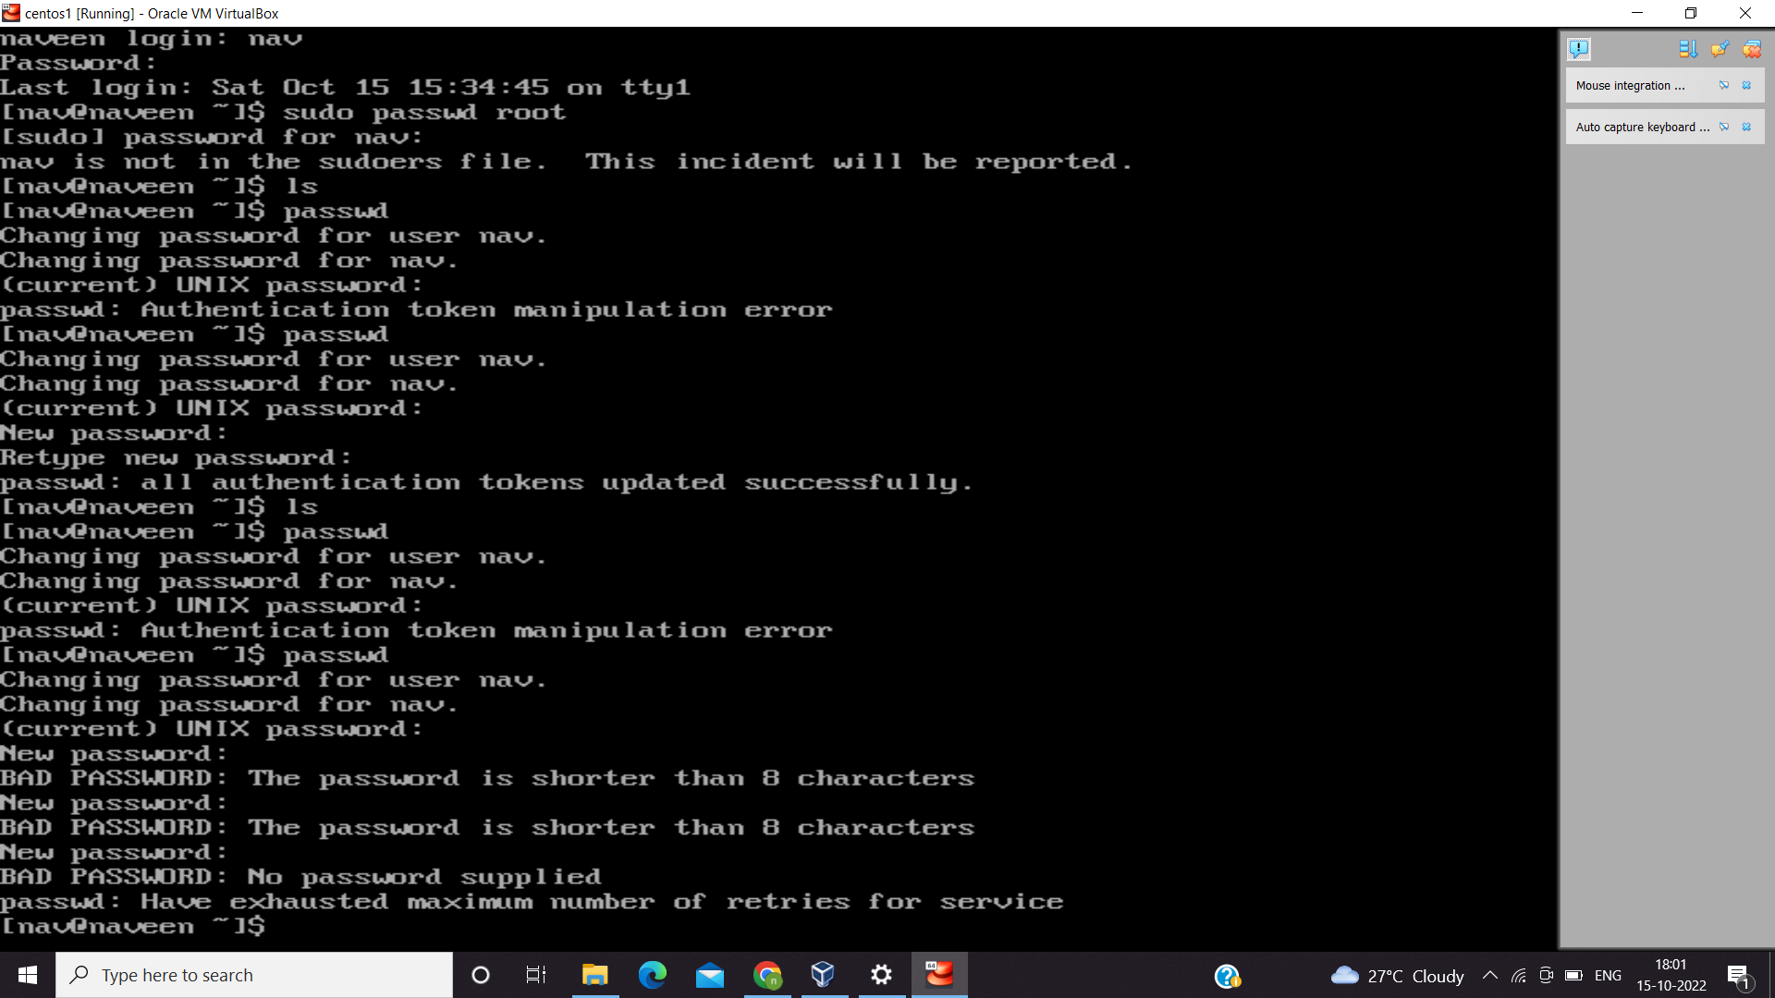

Assignment-3

Working with Directories

* Enter the command **cd /** and then **ls** and then hit **Enter** key
  + Take screenshot and explain what output we got?

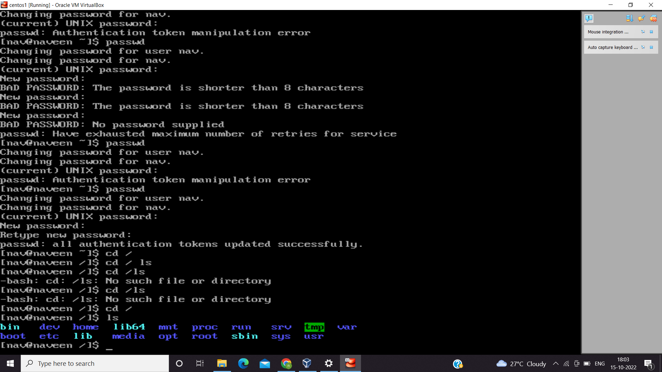

-when cd/ is given it moves to parent or root directory and ls shows the list of files and directories.

* Enter the command now **cd /home** and then hit **Enter** key
  + Do **ls,** provide screenshot and explain what is **/home** directory used for?

-A home directory is a file system directory containing files for a given user of the system.

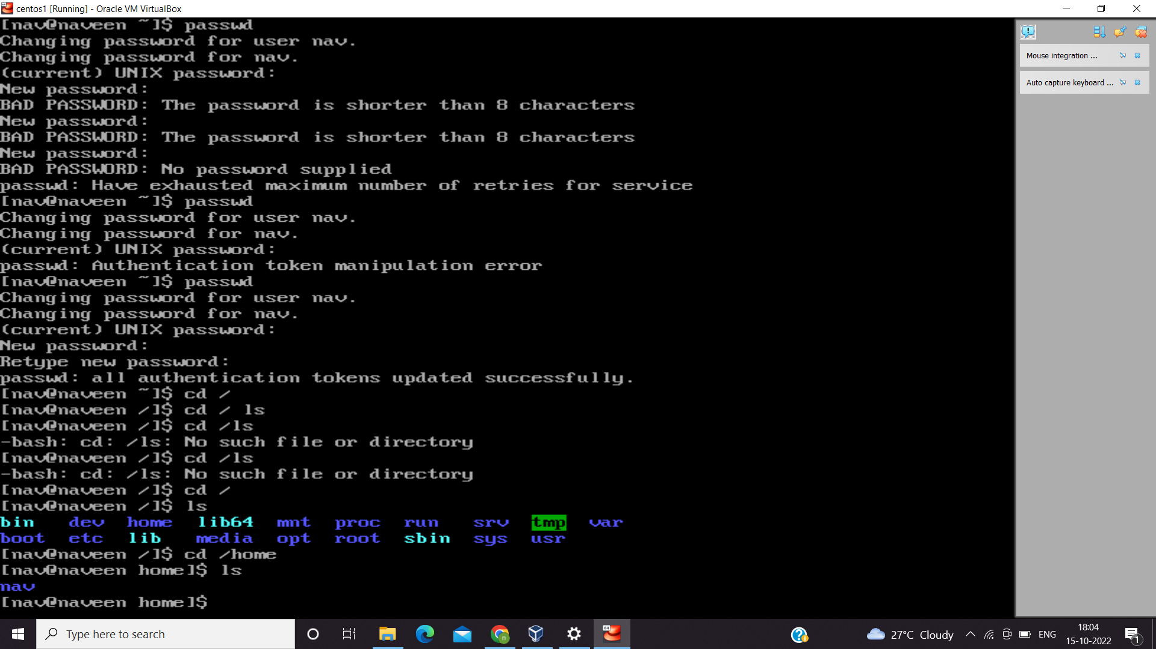

* Enter **cd ..** and hit **Enter** key [ *Note: here we have space after cd then use double dot*]
  + Check what happen and give screenshot?

-it moves back to parent directory of current directory

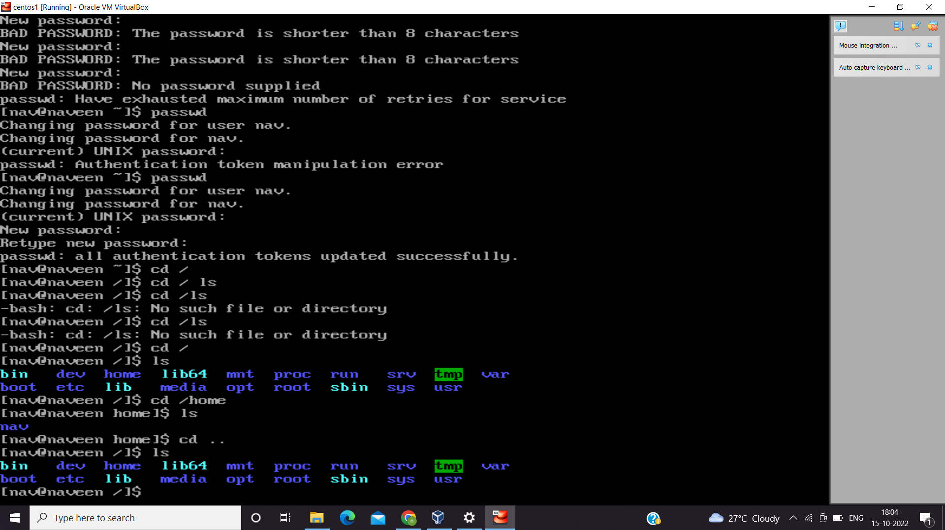

* Now enter **cd /var/www/html** and then type **cd** and hit **Enter** key
  + Explain what happen and give screenshot?

-there is no such file directory

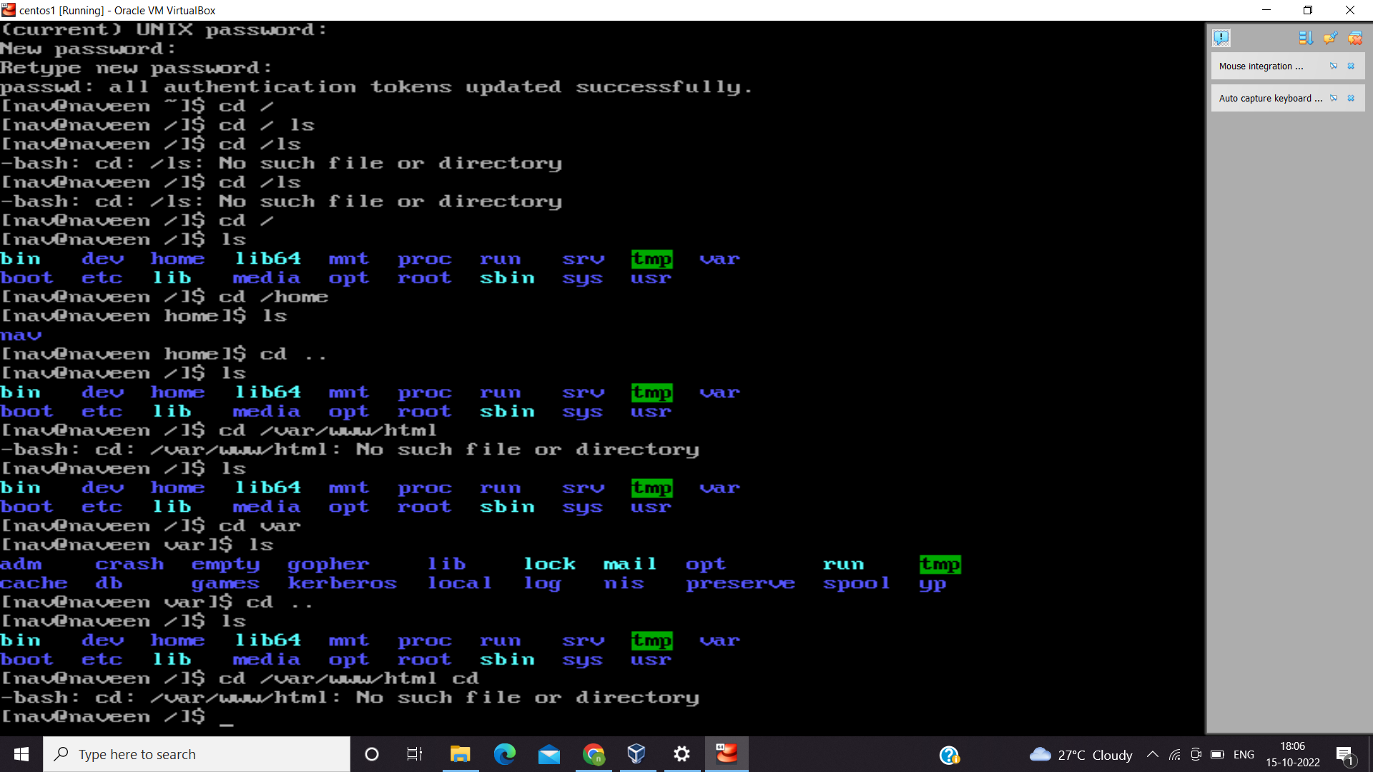

* Now type **cd /root** and then hit **Enter** key
  + Do **ls,** check any output we have on screen if yes then take screenshot?

-got permission denied.

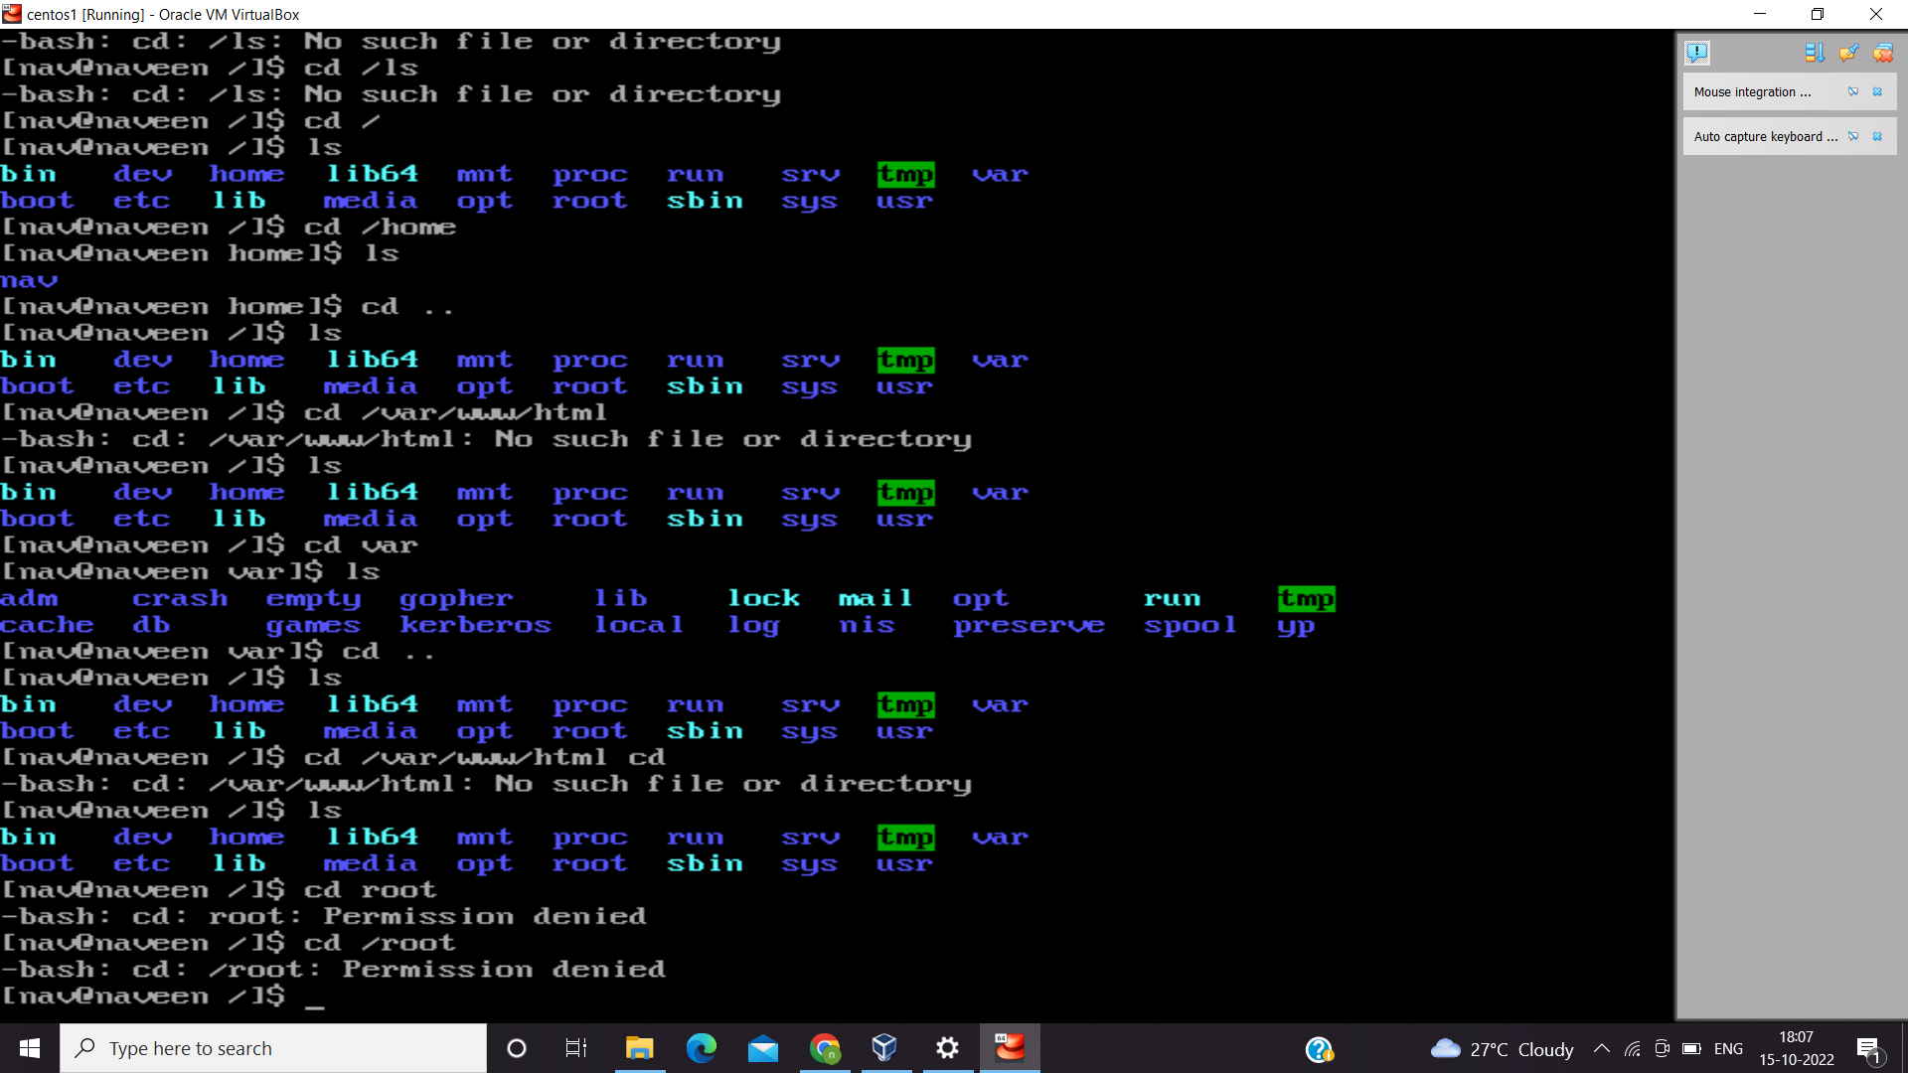

Assignment-4

Working with File Listing

* Go to **cd /etc** and type **ls**
  + Take screenshot and explain what files you have seeing?

-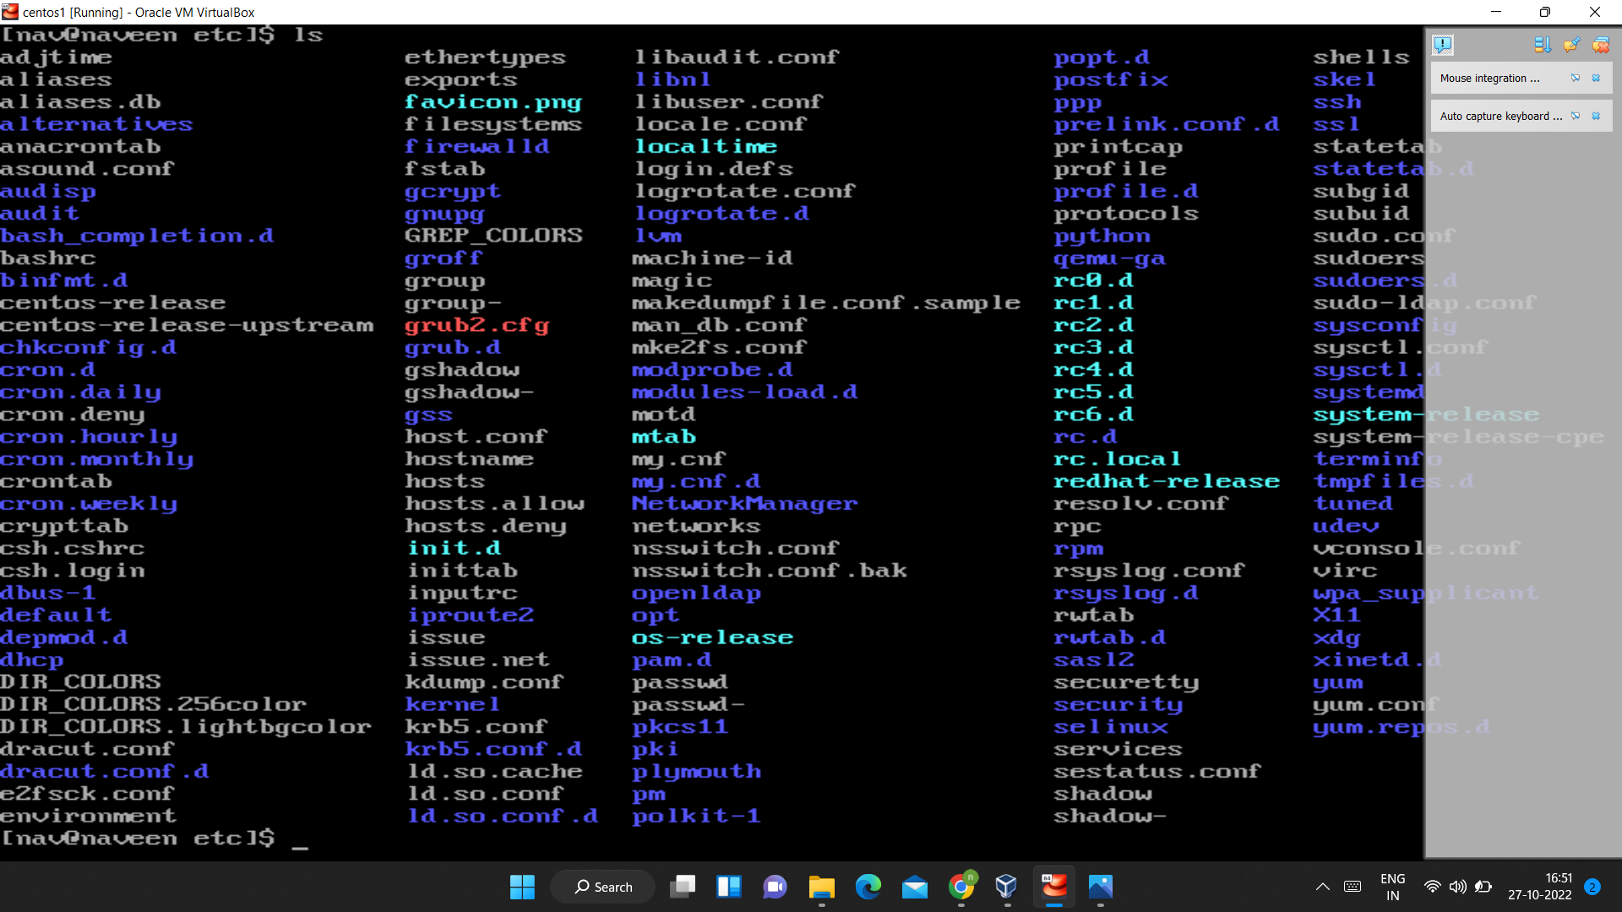

* + Take screenshot and explain what different output you found compare to previous command you used?

-root directory is not accessible without permission whereas etc directory has list of configuration files.

* Then type **ls -al** and hit **Enter** key
  + Take screenshot and explain what new file or directory you found?

-it shows the permissions of configuration files

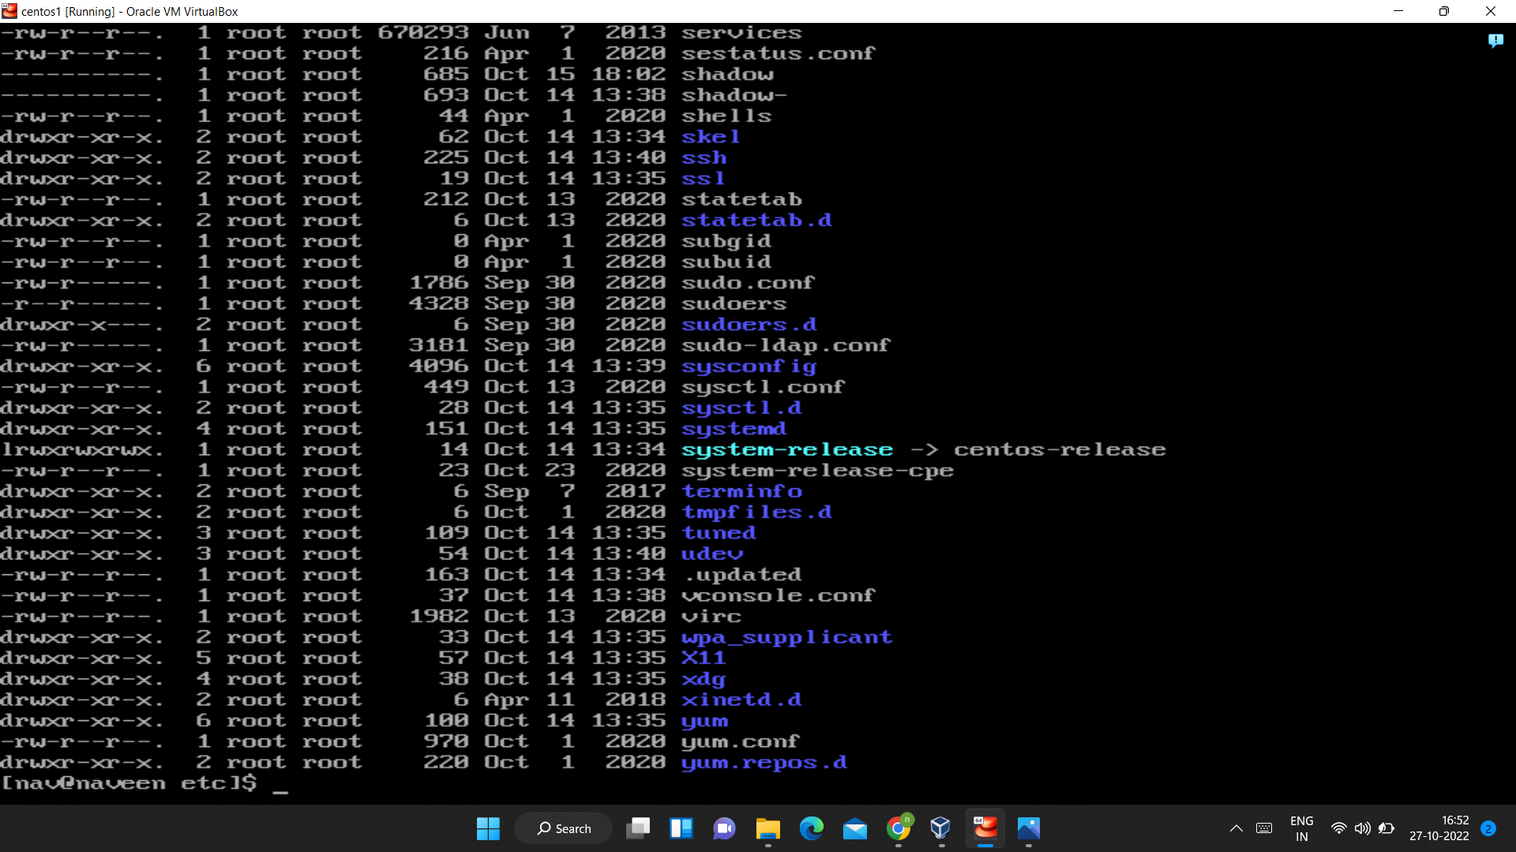

* Then use **ls -i** and hit **Enter** key
  + Now see what different output its shows and take screenshot?

-it displays file index number

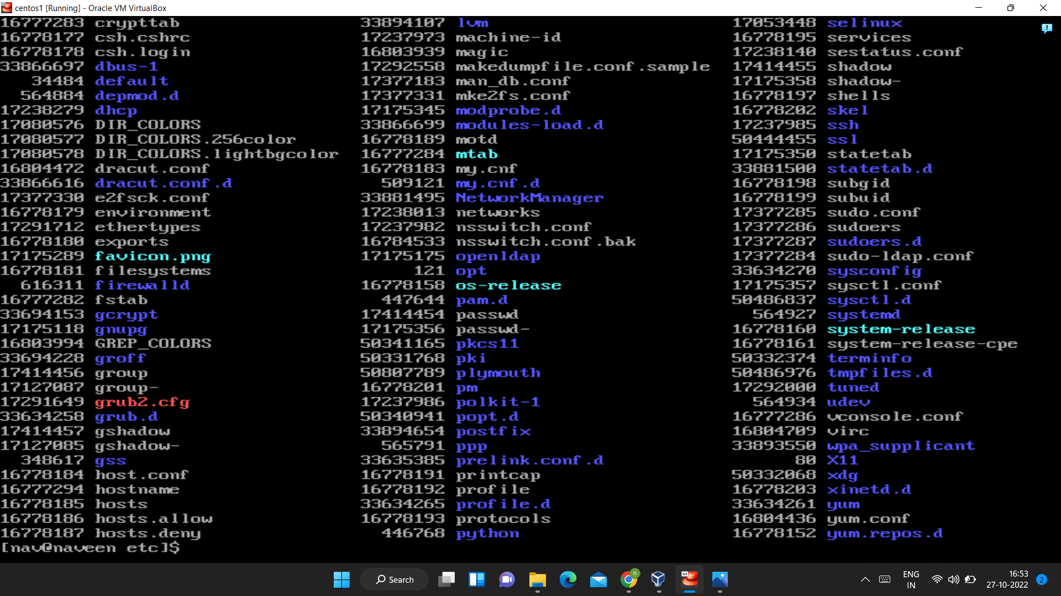

* Then use **ls –help** and see other options about **ls** command
  + Explore it and try with other attribute we can use with **ls** command
* Explored ls commands.

Assignment-5

Know where you are and where you working

*Here we use* ***pwd, cd and ls*** *as combine task to understand where you working on terminal and how you can switch from one directory to another one.*

* Open terminal after restart the linux
  + Check which location you working, type **pwd** and take screenshot

-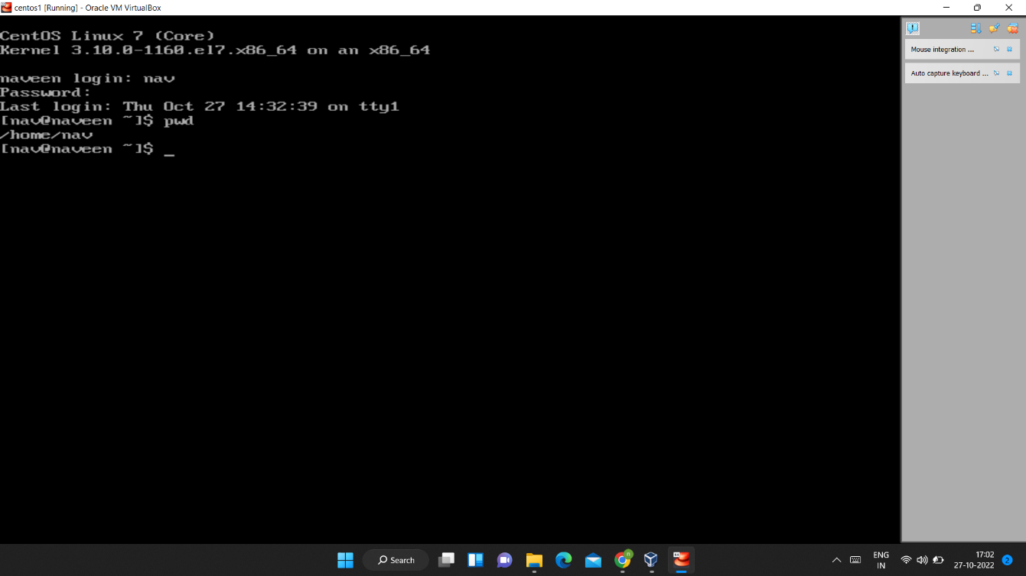

* Now use **cd /var** and hit **Enter** key
  + Do **ls,** and see what output comes, give screenshot?

-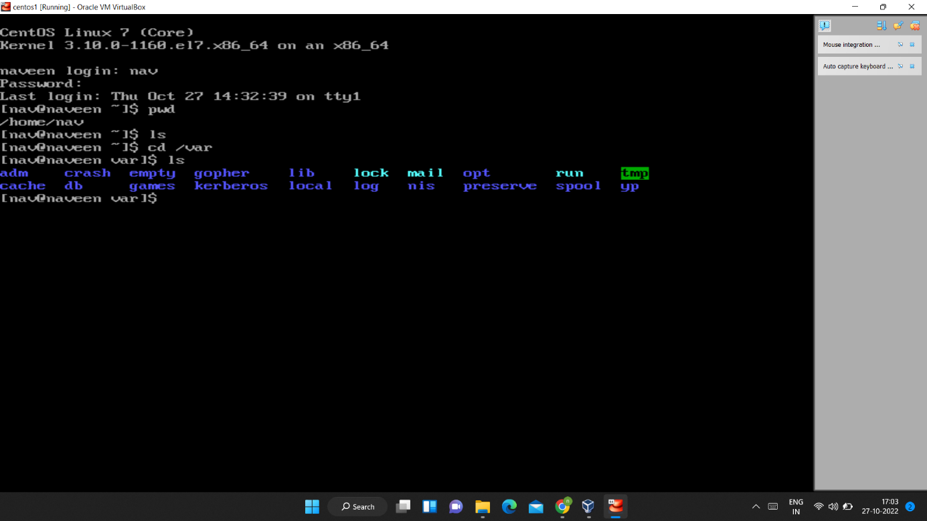

* Do explore other help options of each command to learn more other things we can do with these commands